KS3 SUMMER TERM 3.2
MATHS BLENDED LEARNING
Probability and Statistics
Content | (Please tick if completed)
Week 2 - The Sum of Angles in a Triangle and The Angle Sum in Polygons

Automated PowerPoint Link: https://corbettmaths.com/2012/08/10/angles-in-polygons/

Instructions: Complete each week’s work. The task section is for everyone to try, the challenge task is the extension for that topic.

If you have any questions or would like some feedback, you can contact:
Mrs Mullin on Jessica.mullin@ntsss.onmicrosoft.com
Mr Fernandez on Thomas.fernandez@ntsss.org.uk

Useful Video Links
Week | Video Link
1 | https://youtu.be/dqg1DQCJa-E
2 | https://youtu.be/QEsjIeSnEHU  https://youtu.be/gVo8ZrtlSp0
3 | https://youtu.be/mM-PU6hmkrg  https://youtu.be/ALcBC-p82Q0
4 | https://youtu.be/iWLVTy_rGjs
5 | https://youtu.be/zHlKSFV4QGE  https://youtu.be/6x1-_vA-0-s
6 | https://youtu.be/MS6lnCTgTSw
7 | https://youtu.be/1aGG8KY_GMA

Week 2 - The Sum of Angles in a Triangle and The Angle Sum in Polygons Task
Starter
Round 14.52 to one decimal place: | Simplify a x a
15% of 120 = | 46 + 28.4 =

This week you will derive and use the sum of angles in a triangle and use it to deduce the angle sum in any polygon, and derive properties of regular polygons.
Angles in Triangles
All angles in a triangle add up to 180°
Look at the different types of angles in these triangles…
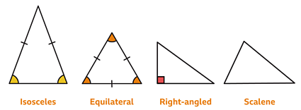
Recognising the type of triangle can help calculate missing angles.

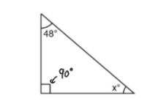
Example:
90 + 48 = 138
180 – 138 = 42
x° = 42°

Question 1) Find the size of each missing angle.
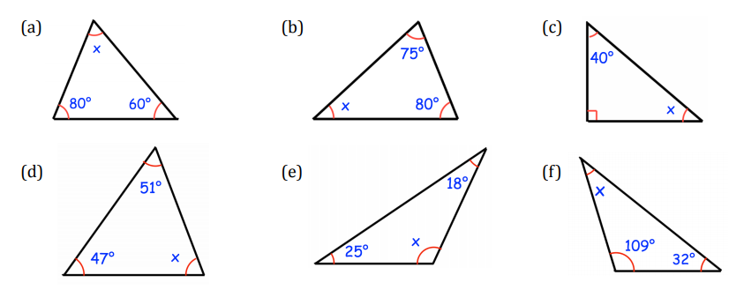

Question 2)
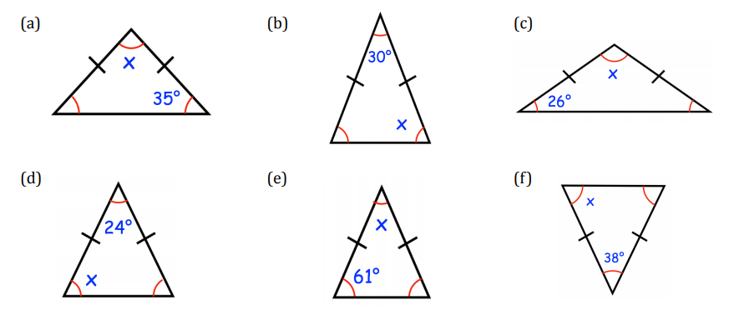

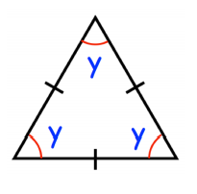
What is the value of y?
Angles in Polygons
A polygon is a 2D shape which has 3 or more straight sides.
In a regular polygon, all the sides are the same length and all the angles are the same size.
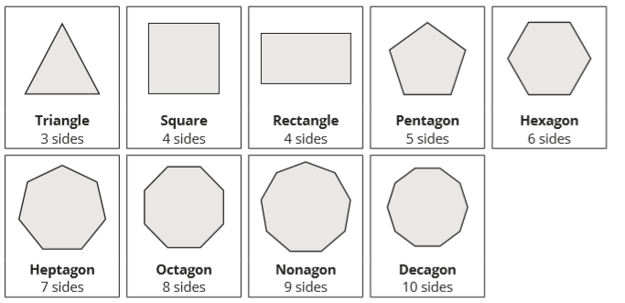
The formula for the sum of the interior angles in a polygon is:
(n – 2) x 180° (n is the number of sides)
We know a square has 4 right angles and 4 sides. Let us see if the formula works!
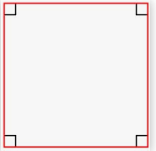
(4 – 2) x 180° = 360° 360° ÷ 4 = 90°
The sum of the exterior angles of a polygon is always 360°. In a regular polygon, to find an exterior angle, you can divide 360° by the number of sides.
360° ÷ n

Shape | Sum of Interior Angles | Interior Angle | Exterior Angle
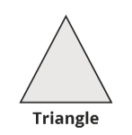 | 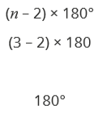 | 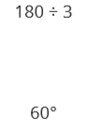 | 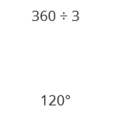
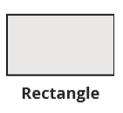
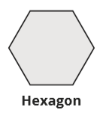
Use the formulas above to work out the angles of these polygons.

Challenge
Question 1)
Jacob has measured the three angles in a triangle. Two of his measurements are 45°and 70° What is the third measurement?

Question 2)
The ratio of three angles in a triangle are 1:2:3. Work out the size of each angle.

Question 3)
An isosceles triangle has one angle of 52°. Write down the possible sizes of the other two angles in the triangle.

Extension
The diagram below has been created using lots of regular polygons. Find all the angles in the shaded shapes contained within the diagram.
