

KS4 Summer 3.2
Content | (Video Links)
Cumulative frequency  (WEEK 5) | https://corbettmaths.com/2012/08/09/drawing-cumulative-frequency-graphs/
Histograms (WEEK 6) | https://corbettmaths.com/2012/08/20/drawing-histograms/

GCSE MATHS WORKBOOK
Probability and Statistics
Instructions: The above content is all of the topic areas within the unit you shall be covering during lessons throughout this half term.

Good luck. Impress us!
Any problems contact Mr. Storey or Mr Seddon on:

Nicholas.storey@ntsss.org.uk kyle.seddon@ntsss.org.uk
Choose your own Challenge
Throughout this booklet you will be given the opportunity to practice and apply the skills we are developing. For each task you can choose your own level of challenge:
- Green – I’m not 100% sure with this task, I’m going to ease myself in.
- Orange – I feel pretty confident that I understand this, I’m going to dive straight in.
- Red – I’m ready for a challenge.

Cumulative frequency
A cumulative frequency diagram creates a running total of the amounts within a table.
Example
The table below shows the lengths of 40 babies at birth.
To calculate the cumulative frequencies, add the frequencies together
Length | Frequency | Cumulative frequency
30 < j ≤ 35 | 4 | 4
35 < j ≤ 40 | 10 | 14 (4+10=14)
40 < j ≤ 45 | 11 | 25 (14+11=25)
45 < j ≤ 50 | 12 | 37 (25+12=37)
50 < j ≤ 55 | 3 | 40(37+3=40)
A cumulative frequency diagram is drawn by plotting the upper class boundary with the cumulative frequency. The upper class boundaries for this table are 35, 40, 45, 50 and 55.

Cumulative frequency is plotted on the vertical axis and length is plotted on the horizontal axis.
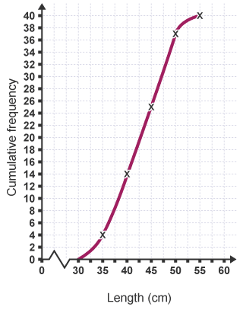

Green
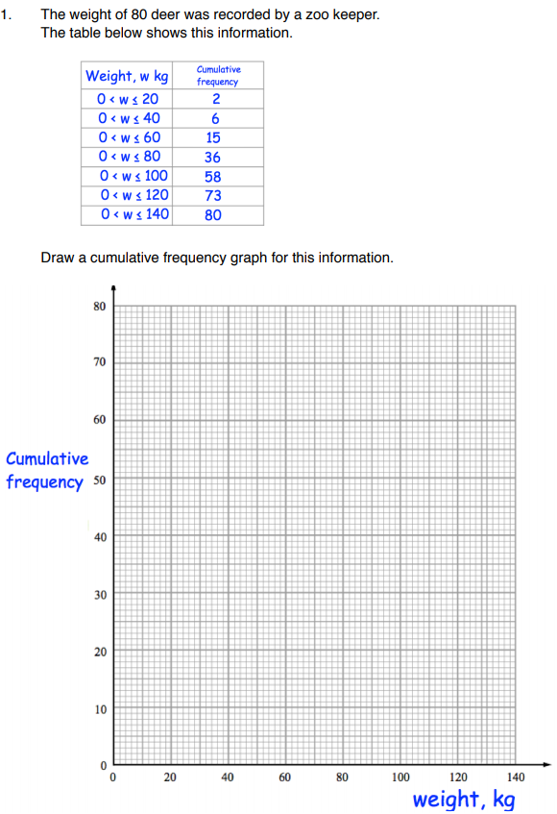
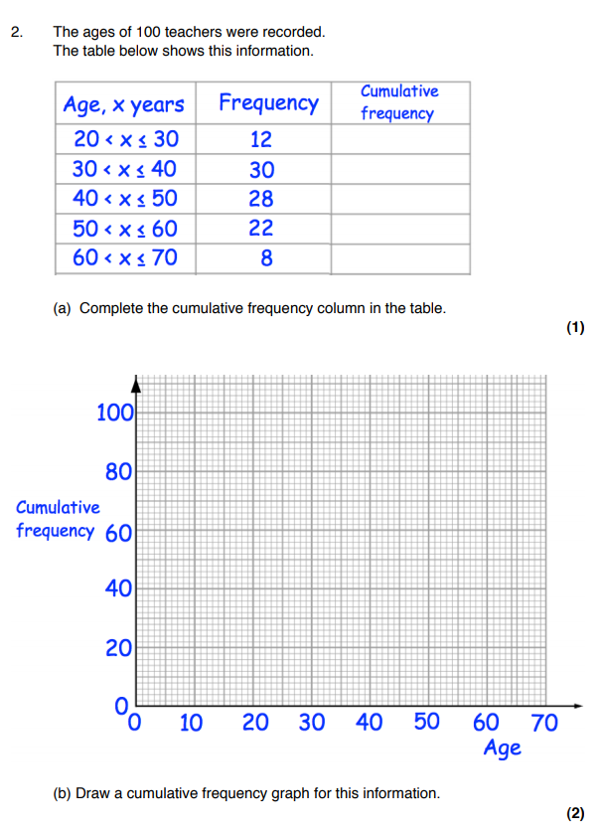

Orange
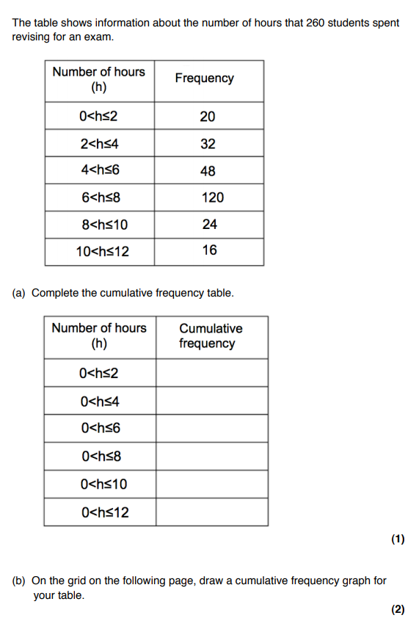
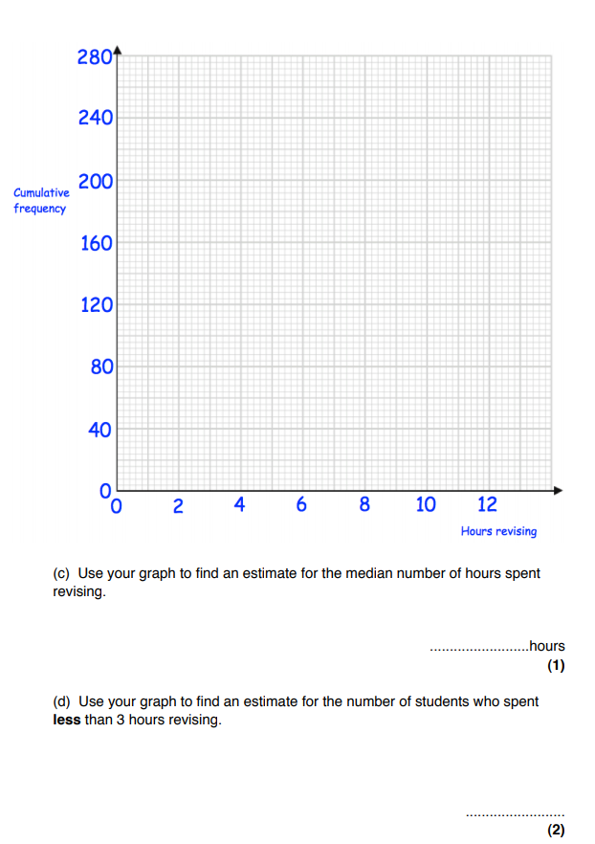
Hint: to find the Median draw a line across from the middle value of the table from the cumulative frequency the read of the value on the x axis to find the median value.

Finding the interquartile range
A cumulative frequency diagram is also a good way to find the interquartile range, which is the difference between the upper quartile and lower quartile.

The interquartile range is a measure of how spread out the data is. It is more reliable than the range because it does not include extreme values. A high value for the interquartile range shows that the data is spread out. A low value for the interquartile range means the data is closer together or more consistent.

Example
There are 40 babies in the table, so to find the lower quartile, find of 40, which is the 10th value. Reading from the graph, the lower quartile is 38.

To find the upper quartile, find of 40, which is the 30th value. Reading from the graph, the upper quartile is 47.

The interquartile range is the upper quartile – the lower quartile, so for this data the interquartile range is 47 – 38 = 9.

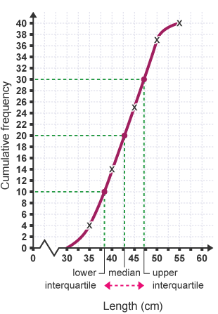
Red
- The weight of 100 tarantulas is given below. Complete the frequency table, draw the cumulative frequency diagram and then estimate the lower quartile, upper quartile and interquartile range
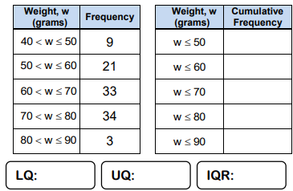
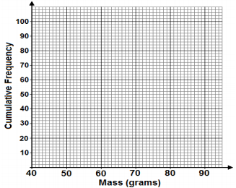

The age of 250 children is shown. Complete all parts of the cumulative frequency table, draw the cumulative frequency diagram and estimate the median and inter-quartile range.
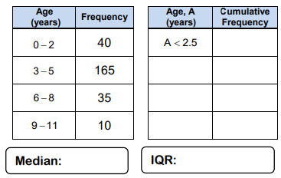
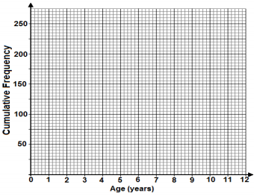

Histograms
A histogram looks like a bar chart, except the area of the bar, and not the height, shows the frequency of the data. Histograms are typically used when the data is in groups of unequal width.
The table shows the ages of 25 children on a school trip.

Age | Frequency
5-10 | 6
11-15 | 15
16-17 | 4
Each class, or category, is not equally sized, which is typical in a histogram question. This is called unequal class intervals.
To draw a histogram for this information, first find the class width of each category.
The area of the bar represents the frequency, so to find the height of the bar, divide frequency by the class width. This is called frequency density.

Age | Frequency | Class width | Frequency density
5-10 | 6 | 6 (5,6,7,8,9 and 10 are in this category) | 6÷ 6=1
11-15 | 15 | 5 | 15÷ 5=3
16-17 | 4 | 2 | 4÷ 2 = 2

Once the frequency densities of the numbers are known, the histogram can be drawn.
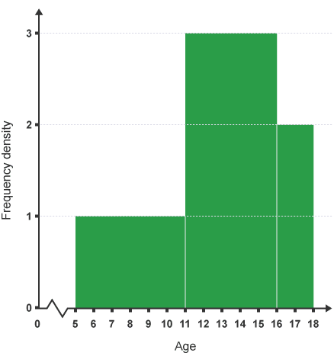
Green
Draw a frequency diagram using the data in each question.
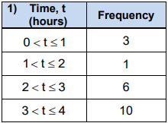
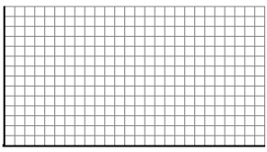
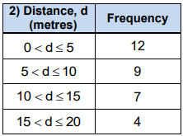
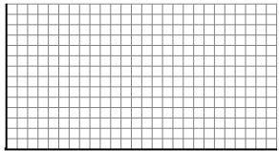
Orange
Draw a histogram for the data in each grouped frequency table.
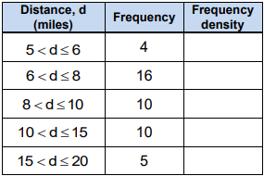

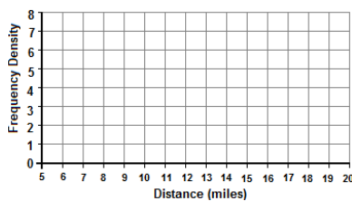

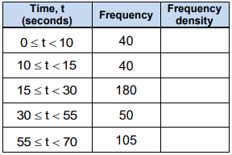

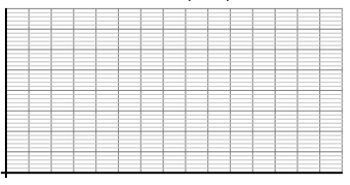

Red
Below is a histogram showing information about the weight of parcels
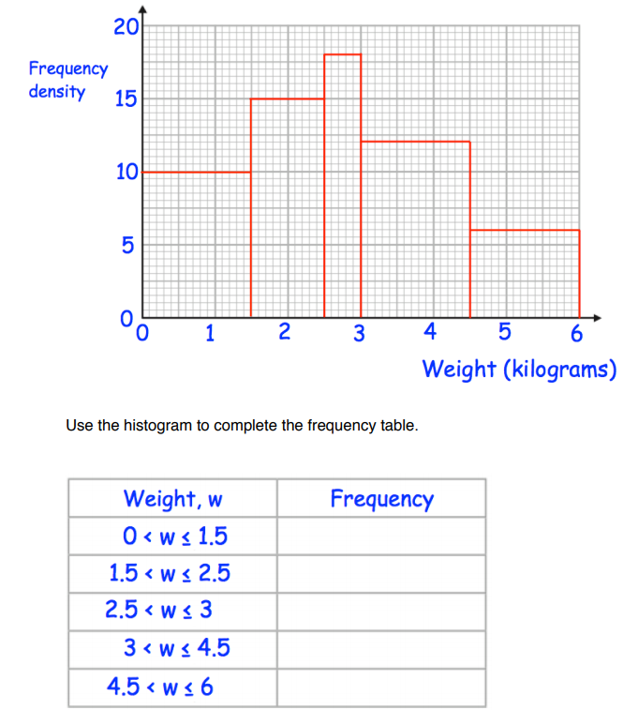

The table and histogram give some information about the heights of plants in a
greenhouse.
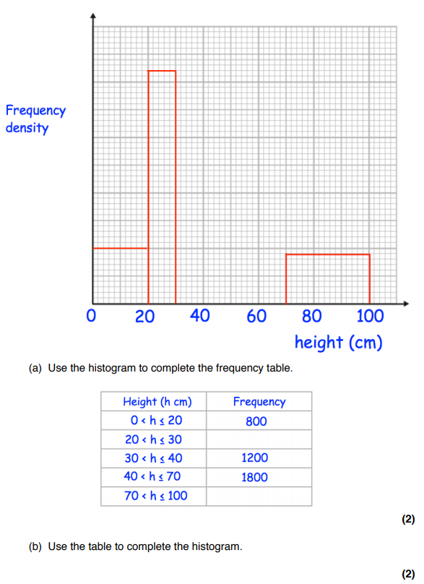

The histogram shows the weights in kilograms of 504 athletes


