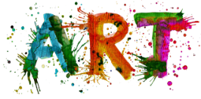
LO: To develop a range of different textures.

Success criteria
To attempt a texture rubbing.
To attempt at least two texture rubbings.
To create a final design of rubbings.

Watch this YOUTUBE video to show you how to do a texture rubbing.
https://youtu.be/4SkOnS3rUoY?t=28
now can you give it a try.
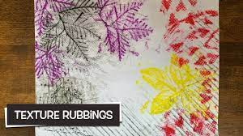
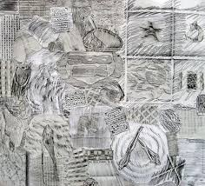
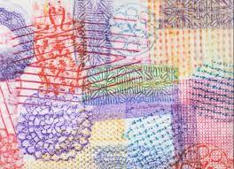

Task 1
Create a simple texture rubbing.
By placing a leaf undeath a sheet of paper and then using a crayon to rub over the top you will start to see a simple texture rubbing.

By applying different pressure with the crayon, you will start to see the texture, shape, and form of the leaf.
The leaf has been placed under the paper.

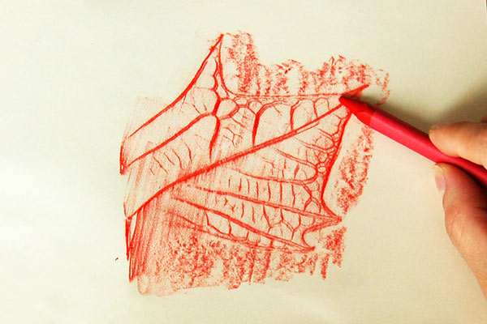

Remember if you do not have crayons, you can use coloured pencil, or a normal pencil. Be extra careful when rubbing.
Task 2
Challenge.
Now try adding more leaves to your paper.

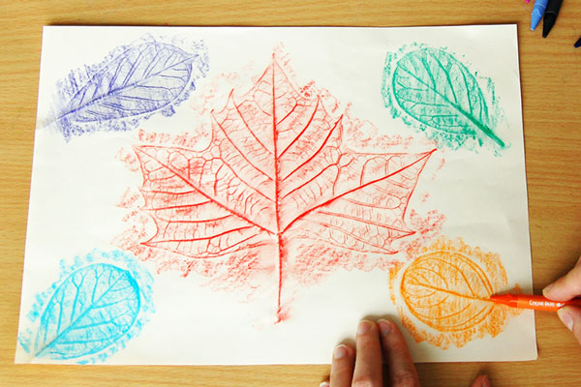

Task 3
Further challenge
Going on a texture hunt.

Now let us stretch and challenge you further. I want you to think about the different types of things you could use to create rubbings.
Like the bottom of your shoe!
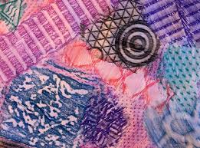
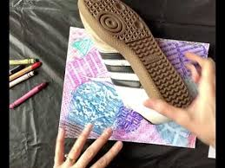

Experiment and have fun and do not be frightened to make a mistake! Remember there is no such thing as mistakes just creative accidents.

Extension task and further challenge.
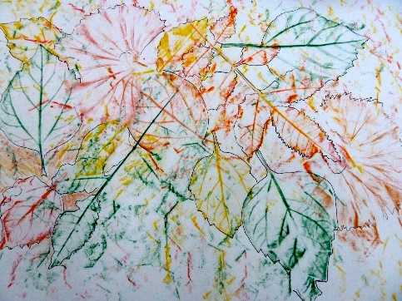
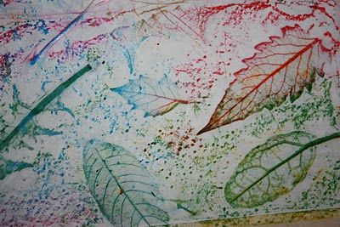
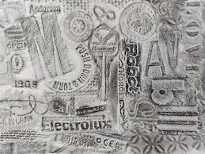
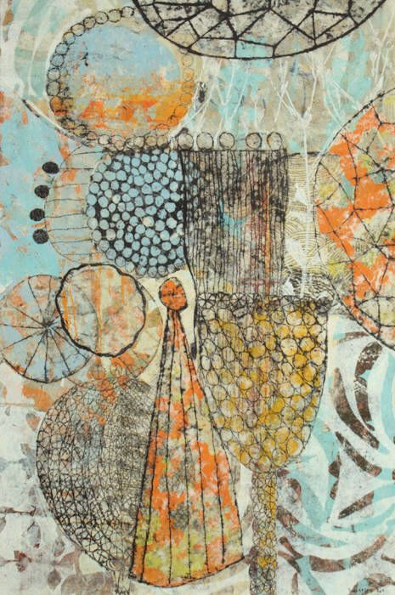
Now we are going to need to really think about this! I now want you to think about a texture design of rubbings. Here are some examples below of what I am looking for and you are aiming to create.

